Smart Object Detection Using Deep Learning and YOLOv8

3 authors:

Simhadri Prasanna Kumar - Y22CD161

Shaik Naimullah - Y22CD160

Singamaneni ManiKumar - Y22CD162


R.V.R & J.C. College of Engineering(A)

Smart Object Detection Using Deep Learning and YOLOv8

Simhadri Prasanna Kumar, Shaik Naimullah, Singamaneni ManiKumar
Department of CSE (Data Science), RVR & JC College of Engineering (Autonomous), Chowdavaram, Guntur, India.
Authors’ contributions
This work was carried out in collaboration among all authors. All authors read and approved the final manuscript.
Under the guidance of

Mrs Swathi Nelavalli – Associate Professor Dept. of CSE (data science)

Abstract
This project introduces a deep learning-based object detection system using YOLOv8 and OpenCV for real-time applications. Unlike traditional methods, it leverages pre-trained YOLOv8 models to achieve high accuracy (91.34%) without manual feature extraction. The system integrates with standard RGB cameras for surveillance, traffic monitoring, and automation, applying confidence-based filtering to reduce false positives. Performance is evaluated using FPS and mAP, ensuring a balance between speed and precision. Scalable YOLOv8 variants allow deployment on diverse edge devices, making this a cost-effective and robust real-time solution.

Corresponding author: Email: naimullahshaik@gmail.com;
Literature Survey
Research Title | Problem Statement | Proposed Methodology | Parameters
[1] R-CNN Framework (R. Girshick et al.) | Traditional object detection methods were slow and inaccurate | R-CNN: Used region proposals combined with CNNs for classification. | R-CNN: Accuracy, Processing Time, Computational Cost
[2] YOLO: You Only Look Once (J. Redmon et al.) | Two-stage detectors were slow for real-time applications. | YOLO: Developed a one-stage object detection algorithm that detects objects in a single pass. | YOLO: Speed, Accuracy, Detection Rate
[3] Single Shot MultiBox Detector (W. Liu et al.) | Traditional methods lacked efficiency in real-time detection. | SSD: Utilized multi-scale feature maps and convolutional filters. | SSD: Speed, Small Object Detection, Accuracy
[4] YOLOv4 (A. Bochkovskiy et al.) | Previous YOLO versions lacked efficiency in feature extraction. | Integrated CSPDarknet-53, SPP, and PANet to enhance feature extraction. | Speed, Feature Extraction, Inference Time.
[5] YOLOv5 (G. Wang and Y. Chen) | Object detection models were not optimized for edge devices. | Developed a lightweight and scalable model for real-time applications. | Speed, Model Size, Hardware Compatibility.
[6] YOLOv8 (D. Jocher et al.) | Anchor-based object detection models had limitations in accuracy. | Introduced an anchor-free architecture with decoupled head and C2f modules. | Accuracy, Speed, Inference Time.
[7] CNN-based Surveillance Detection (M. Patel & S. Kumar) | Object detection in surveillance was affected by lighting conditions. | Used CNN models trained on labeled datasets. | Detection Speed, Adaptability, Accuracy
[8] Fire Detection System (A. Singh & V. K. Sharma) | Existing fire detection lacked learning capability for dynamic environments. | Implemented image processing with SVM and KNN. | Accuracy, False Alarm Rate, Adaptability
[9] YOLOv3 with OpenCV (S. Mehta et al.) | small object detection was challenging in real-time applications. | Integrated YOLOv3 with OpenCV for faster processing. | Speed, Small Object Detection, Precision
[10] Hybrid CNN – Edge Detection (P. Srivastava & M. Gupta) | Conventional object detection lacked precision. | Combined CNN with edge detection filters for preprocessing. | Accuracy, Processing Overhead, Precision
[11] Faster R-CNN for Real-Time Object Detection (V. Bansal et al.) | Faster R-CNN was computationally expensive for continuous video processing. | Used Faster R-CNN for object detection. | Detection Speed, Computational Cost, Hardware Efficiency

Proposed Work
We propose a real-time object detection system using YOLOv8m integrated with OpenCV for live video processing. The system calculates mean confidence per frame and tracks class-wise detection statistics for better interpretability. Confidence-based bounding box coloring differentiates high and low-confidence detections. It enhances detection accuracy, reliability, and real-time performance. This approach is ideal for surveillance, monitoring, and edge-device applications. We propose a real-time object detection system using YOLOv8m integrated with OpenCV for live video processing. The system calculates mean confidence per frame and tracks class-wise detection statistics for better interpretability. Confidence-based bounding box coloring differentiates high and low-confidence detections. It enhances detection accuracy, reliability, and real-time performance. This approach is ideal for surveillance, monitoring, and edge-device applications
Methodology
this project employs YOLOv8 for real-time object detection using OpenCV to process live video from a webcam. The YOLOv8m.pt model is chosen for its balance between accuracy and speed, making it ideal for real-time applications. Frames are continuously captured and processed, with detected objects displayed using bounding boxes and confidence scores. A confidence threshold of 0.5 filters low-confidence detections, marking high-confidence objects in green and low-confidence ones in red. The system also computes mean confidence scores per frame and dynamically updates class-wise detection statistics.
Dataset
the COCO 2017 dataset is a widely used benchmark for object detection, segmentation, and keypoint detection. It contains 118,287 training images, 5,000 validation images, and 40,670 test images, covering 80 object categories. With over 1.5 million labeled instances, it ensures diverse object representation for deep learning models like YOLOv8. The images, stored in JPEG format, range from 480×640 to 1280×1024 pixels with RGB channels. Its rich diversity in lighting, occlusions, and object types enhances model accuracy and real-world adaptability.
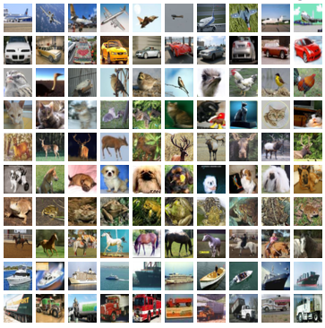
Fig.1. Pictures in the Dataset
Architecture Of YOLOv8
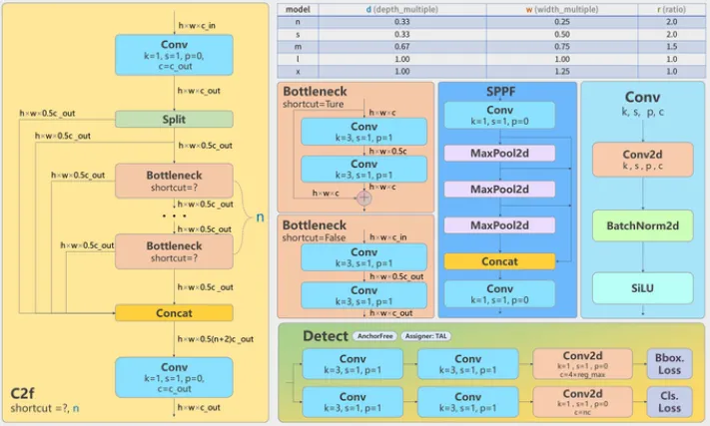
Fig.2. Architecture of YOLOv8.
YOLOv8's architecture is a streamlined and highly effective design focused on versatility and performance. Here's a concise summary:
- Anchor-Free & Decoupled Head: It simplifies detection by eliminating anchor boxes and separating classification and regression tasks.
- C2f Backbone: Uses the efficient C2f module for robust feature extraction.
- Improved Neck: Enhances feature fusion for better multi-scale object detection.
- Scalable: Offers various model sizes (n, s, m, l, x) for different computational needs.
- Versatile: Supports object detection, segmentation, and classification, making it adaptable to diverse applications.
- Modern Design: Leverages contemporary architectural choices for increased accuracy and efficiency compared to earlier YOLO versions.

Flow Diagram
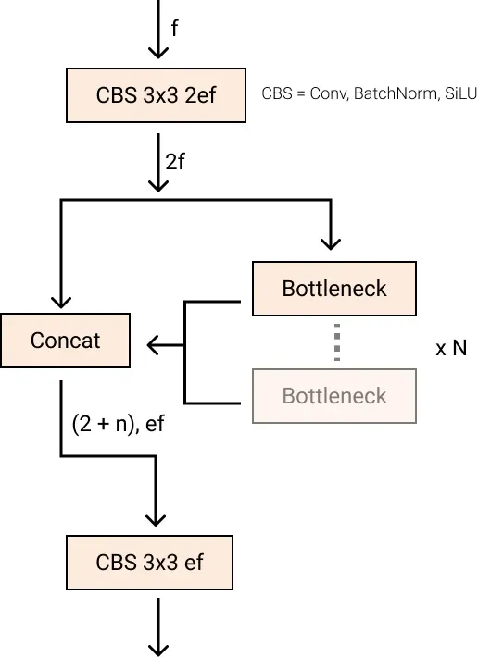
Fig.3. Flow Diagram
This flow diagram depicts the C2f module in YOLOv8, which:
- Splits input features.
- Applies Bottleneck blocks to one branch.
- Concatenates both branches.
- Uses CBS (Conv-BatchNorm-SiLU) layers for channel adjustment.
It efficiently enhances feature extraction and aggregation.

Results
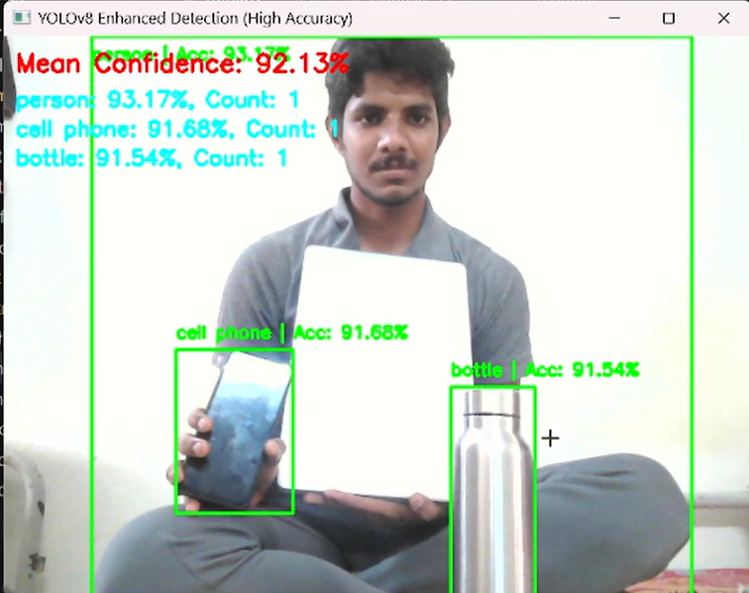
Fig.4. Results Multi Objects with Accuracy Meter

Testing types
Functional Testing
- This ensures that the YOLOv8 model detects objects correctly and the program runs as expected.
Performance Testing
- Evaluates the speed and efficiency of real-time object detection.
Accuracy Testing (Evaluation Metrics)
- Tests the accuracy of detections using standard object detection metrics.
Usability Testing
- Ensures that the system is user-friendly and meets user needs.
Security Testing
- Ensures the system is protected against vulnerabilities.
Robustness & Stress Testing
- tests how well the system handles extreme conditions.
Integration Testing
- Checks how well the object detection model integrates with other components.

Applications of YOLOV8 Model
Autonomous Vehicles – Used for real-time object detection to identify pedestrians, vehicles, and obstacles for safe navigation.

Surveillance & Security – Helps in monitoring CCTV footage to detect suspicious activities, intrusions, or unauthorized access.

Medical Image Analysis – Assists in detecting diseases from X-rays, MRIs, and CT scans with high accuracy.

Retail & Inventory Management – Used for automated checkout systems and tracking stock levels in warehouses.

Agriculture & Farming – Helps in crop monitoring, pest detection, and livestock tracking through drone-based surveillance.

Augmented Reality (AR) & Robotics – Enables object recognition and tracking for interactive AR applications and robotic vision systems

Conclusion & Future Scope
This project successfully integrates YOLOv8 with OpenCV for real-time object detection, achieving accurate and efficient recognition of multiple objects in live video feeds. The system dynamically filters detections based on confidence scores, improving reliability and interpretability. Real-time statistical updates enhance object detection insights, making it suitable for applications like surveillance and autonomous navigation. Future improvements can focus on optimizing detection speed for edge devices and integrating cloud-based AI for remote processing. Expanding the dataset with additional object categories can improve accuracy for specialized tasks. Features like multi-camera support, real-time tracking, and action recognition can further enhance its applications. Implementing deep learning-based post-processing techniques will help refine classification and reduce false positives.

References
[1] YOLOv8 Official Documentation – https://docs.ultralytics.com
[2] OpenCV Library – https://opencv.org
[3] COCO Dataset – https://cocodataset.org
[4] Ultralytics YOLO GitHub Repository – https://github.com/ultralytics/ultralytics
[5] Real-Time Object Detection Using YOLO – https://pjreddie.com/darknet/yolo/

